Electromagnetic Projectile Launcher

Jonathan Pilling

ECE2240 Lab Section 02

***Abstract-*Building an electromagnetic paperclip launcher that consisted of a hand-wound coil, capacitor, resistor, and switch. With the switch activated we were able to create a nearly critically damped circuit that caused rapidly changing current pulse. At the center of this coil, the paperclip launched away into the great beyond.**

**I. Introduction**

Scientist and engineers have explored electromagnetic launchers for possible applications such as launching projectiles or space vehicles. A coil gun consists of a series of coils, with the projectile placed inside. Applying a short high-current pulse to the coils produces magnetic field forces that push the object through the coils with extreme velocity. In the circuit we created, the left side is the charging circuit for the capacitor. This capacitor has a resistor to limit the current flowing into itself. After charging up the capacitor, at time t = 0, the switch will flip and put the charged capacitor in series with an inductor and another resistor.

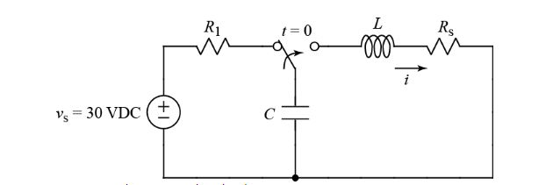

Figure 1. Electromagnetic Circuit Schematic

In this report we will discuss the design for the capacitor charging circuit, the analysis of the circuit, and the construction of the launcher circuit. Finally, we will discuss optimizing launcher values to give critically damped conditions.

**II. Capacitor Charging Circuit Design, Construction**

In designing the left side of Fig. 1, we need to model the voltage across the capacitor with a differential equation. As soon as the switch is flipped in the circuit, the voltage will be supplied by the capacitor, and over time this will eventually reach 0 volts.

|  |  |  |
| --- | --- | --- |
|  |  | (1) |

When the capacitor is fully charged, the voltages between the source and the capacitor will be equivalent. Using the general solution for an RC circuit we can rewrite the Voltage across the capacitor as a function of time.

|  |  |  |
| --- | --- | --- |
|  |  | (2) |

Now, with our expression we can easily model the changing current through the capacitor, which should approach zero as time goes on infinitely.

|  |  |  |
| --- | --- | --- |
|  |  | (3) |

In the left side of the circuit, we can use a resistor value that will limit the current to 1.5 mA. Replacing the 30 V source with a temporary 3 V source, we can calculate our resistor value to be 2 kΩ.

**III. Analysis of Launcher Circuit**

After the switch is flipped in the circuit, we can determine the initial conditions, and we can set up a second order differential equation using the 2 cases for our temporary capacitance. The first case is where we have C = 2000 µF. The second case is where we have C = 2000 nF. Refer to Fig. 1 where we have the RLC components in series, our values of L = 80 µH, and R = 0.7 Ω. General solution for a second order RLC (series) circuit gives us Eq. 4.

|  |  |  |
| --- | --- | --- |
|  |  | (4) |

In our case where C = 2000 µF, we get a circuit that is overdamped. This works out because there are two real roots for the RLC circuit. Also important to note, we calculated two frequencies from this circuit. The neper frequency, denoted α, was equal to 4375 rad/s. The resonant frequency, denoted $ω_{0}$, was equal to 2500 rad/s. Using the general solution for an overdamped circuit we were able to derive below equation.

|  |  |  |
| --- | --- | --- |
|  |  | (5) |

The underdamped solution was a little more complex, but thankfully we were able to plot it using MATLAB.

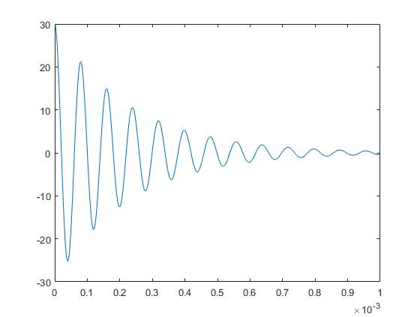

Figure . Underdamped solution plot